OOP: Lab 2 – Multiform with Objects

Items included in Lab:
Lab2SolutionFile
InitialValues.txt
LoadValues.txt

After opening up the Lab2 Solution. You will find an existing Form. You will need to create a GroceryItem class with the following members:
Properties
Name | Type
ItemID | Int
Name | String
Price | Decimal
BestBefore | DateTime
Description | String
Constructors
Create a custom constructor taking in all of the values needed for the above properties.
Methods
Name | Input Parameters | Returns
OutputValues | None | string
Use this method to output all of the property values with a separator. This will help with saving the values back into a useable file.
The order the properties are listed in is the order that the values are stored in the text files! You can use auto-implemented properties if it makes sense, however, you may wish to create your own fields and properties with getters and setters where it might be helpful (think data validation!).

You will need to create a second form (frmEditForm). No specific design requirements, however, it should look professional.

Initial Form Load:
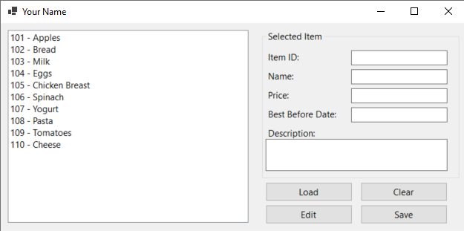

As a user of the application, I want the following functionalities to be available:
- Initial Form Load:
- As a user, when I first run the application, the form should load with initial values.
- These initial values should appear in the list box.
Requirements:
- The form should be titled with your name.
- The list box should display the ID and Name of the items.
- Viewing Item Details:
- As a user, when I click on an item in the list box, I expect all the item's values to be displayed in the labels on the right-hand side.
- Loading Items from File:
- As a user, when I click the Load button, I should be prompted to select a file to load.
- The results from the selected file should populate into the list box.
- Clearing Values:
- As a user, when I click the Clear button, all values should be cleared out.
- This includes clearing the list box, labels with values, and the entire list.
- Saving Items to File:
- As a user, when I click the Save button, all items in the list should be saved to the file I select.
- They should be saved in the same format as the provided text files (I should be able to Load a saved file!)
- Editing Item Details:
- As a user, when I click the Edit button, a new form should open.
- The new form should allow me to edit the item fields (excluding the ID field).
- The form should have an "Accept Changes" button to update the associated item and close the edit form.
- Validation for Input:
- When editing or adding items, there should be validation checks to ensure that required fields are not left blank, and appropriate data types are used (e.g., non-negative numeric values for Price, valid date formats).

Helpful Hints!

List Boxes can hold Objects! However, by default they use the item’s ToString() method to display it, which won’t give you a very nice result. So, if you choose to store Objects in the list box, you can display as per specs by Overriding the ToString() method for your class!
public override string ToString()
{
// choose any format that suits you and display what you like
return String.Format("{0} - {1}", ItemID, Name);
}

You can set the file for your InitialValues to copy out to the Bin/Debug folder to make a simple path. You can access the Copy to Output Directory property by clicking on the file in Solution Explorer:

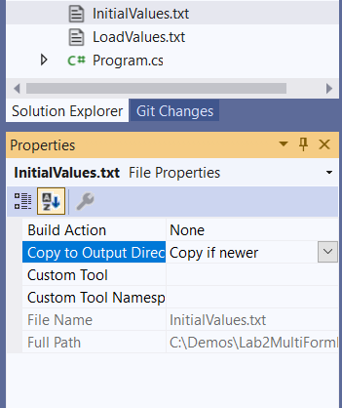

Passing Data between Forms
Several methods were discussed / demonstrated in class. You can use any of these methods (or others if you comment where you found it and why you chose it!). We discussed passing data through the form’s constructor, using the Tag property and by setting the appropriate controls on the forms to public. However, don’t forget if you are passing an object, that it is a reference type!

Parsing the Data
The load files are coming in as comma separated but are not .csv files. You can simply read them as any other text file and then manage the data line by line. If you haven’t used it, string.Split() is a helpful tool!

